Chapter-3 Decorator Pattern

This is what is given to us.
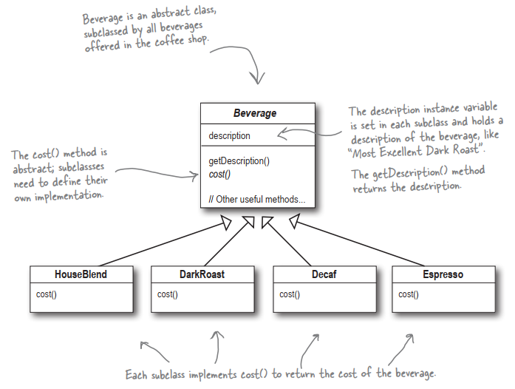

This is their first design idea:


